E-mail to parents
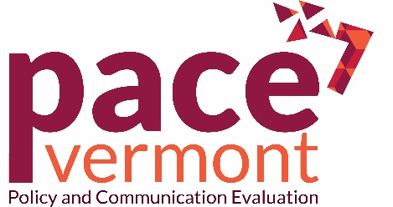

Your child is invited to participate in Vermont’s first Policy and Communication Evaluation (PACE Vermont). PACE Vermont will study the effects policy and communication efforts have on youth substance use. Led by an expert research team from the University of Vermont’s Center for Behavior and Health and the Vermont Department of Health, PACE Vermont will help direct substance use prevention resources where they are needed most.
Until now, Vermont public health experts have relied on youth surveys done every two years to inform substance use prevention efforts. But we know a lot can happen in two years! By surveying 2,000 youth ages 12-17, PACE Vermont will help close this knowledge gap on rapidly changing questions, such as:
- How do youth feel about and use alcohol, tobacco, marijuana or other drugs?
- What is happening with trending or new and emerging products (for example, JUUL)?
- What effects do legalized marijuana and other substance use policies/laws have on youth?
- Are statewide substance use prevention campaigns working?
This is a unique opportunity for your family to contribute to a body of knowledge that will be used to improve the health of Vermont’s young people for years to come. The study will also help us learn how to best recruit and retain youth and young adults for future surveys.
You will have access to the study’s progress, key findings, and the ability to connect with other families on PACE Vermont’s social media sites. You and your child can also earn gift rewards.
Step 1: Give Parental Permission
Visit pacevt.org to electronically sign the permission form allowing your child to participate in three online surveys over the course of six months. You will provide your child’s e-mail address or cell phone number for us to contact them directly about the survey.
Step 2: Take Brief Online Youth Survey
If you child chooses to participate, they will click the survey link delivered via e-mail or text message. After completing the first survey, they will be invited by email or text message to participate in the next two online surveys at 3 and 6 months after PACE Vermont begins. Each survey takes 10-15 minutes to complete. All surveys are voluntary. All answers are confidential.

Step 3: Receive Gift Rewards
Parents can earn $5 in online gift cards for referring other eligible families to participate (up to $15 total in online gift cards). Youth participants will receive at least $50 in online gift cards for completing all three surveys.
Thank you for your consideration. To learn more about the study or to give your child permission to participate, please visit pacevt.org.
Sponsored by:
